**Convert MHTML Files to PDF Documents Using ASP.NET Core**

The Syncfusion; [**HTML-to-PDF converter**](https://www.syncfusion.com/document-processing/pdf-framework/net/html-to-pdf) is a PDF library for converting webpages, SVG, MHTML, and HTML files to PDF using C#. This guide covers the necessary steps, tools, and code examples to help you integrate MHTML to PDF conversion into your [.NET Core](https://www.syncfusion.com/document-processing/pdf-framework/net-core) applications.

**Steps to Convert MHTML to PDF Programmatically**

1**. Create a New Project**: Start a new Console application in .NET Core to facilitate the HTML-to-PDF conversion process. 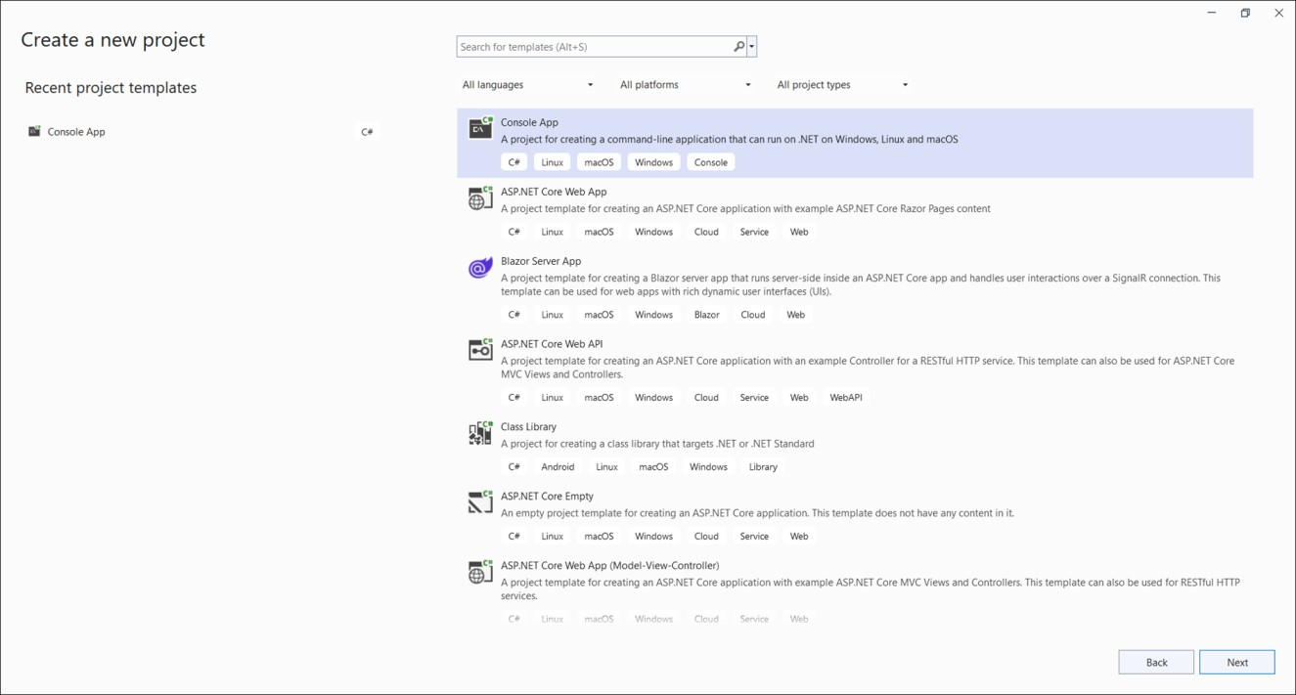

2. **Install Required Packages**: Add the [Syncfusion.HtmlToPdfConverter.Net.Windows](https://www.nuget.org/packages/Syncfusion.HtmlToPdfConverter.Net.Windows) NuGet package from [NuGet.org](https://www.nuget.org/) to your project.

3. **Set Up Your Environment**: In the **Program.cs** file, include these namespaces.  
**C#**

|  |
| --- |
| **using** Syncfusion.HtmlConverter;  **using** Syncfusion.Pdf; |

4. **Implement the Conversion Logic**: Use the following code snippet in **Program.cs** to convert an MHTML file to a PDF document.  
**C#**

|  |
| --- |
| // Initialize HTML to PDF converter  HtmlToPdfConverter htmlConverter = new HtmlToPdfConverter();  // Convert the MHTML content to PDF  PdfDocument document = htmlConverter.Convert("Data/Input.mhtml");  // Save the PDF document to a file  using (FileStream outputFileStream = new FileStream("Output.pdf", FileMode.Create, FileAccess.ReadWrite))  {  document.Save(outputFileStream);  }  // Close the PDF document  document.Close(true); |

A complete working sample can be downloaded from  [**GitHub**](https://github.com/SyncfusionExamples/PDF-Examples/tree/master/HTML%20to%20PDF/Blink/MHTML-to-PDF/.NET).

By executing the program, the output PDF document will be generated as shown below:

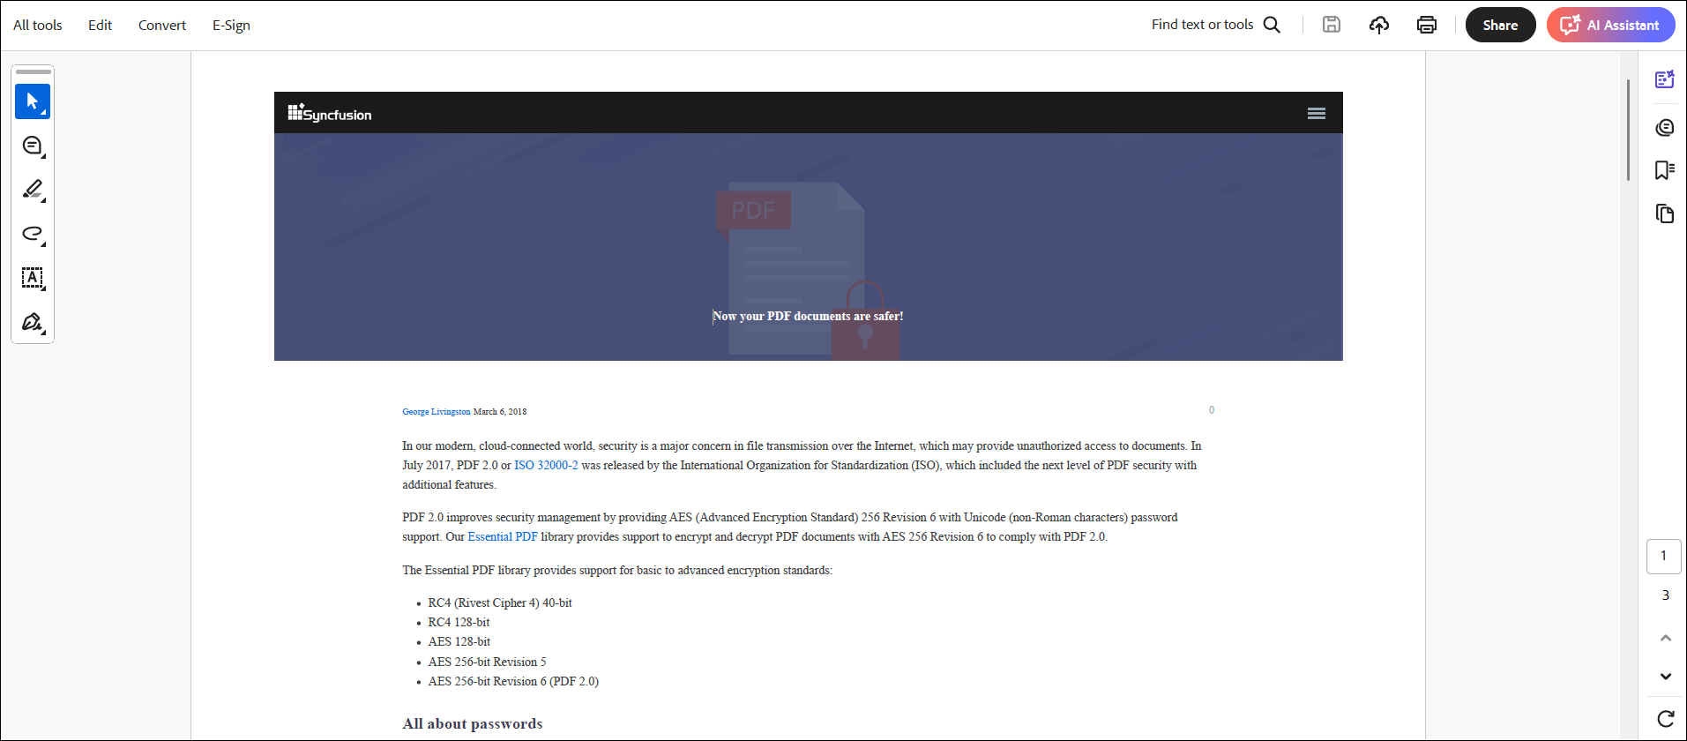

Take a moment to peruse the [**documentation**](https://help.syncfusion.com/document-processing/pdf/conversions/html-to-pdf/net/features), where you will find features for converting HTML pages into PDF documents.

**Conclusion**  
We hope this guide helped you learn how to convert MHTML files to PDF documents using the .NET Core PDF library.

You can refer to our [**ASP.NET Core PDF feature tour**](https://www.syncfusion.com/document-processing/pdf-framework/net-core) page to know about its other groundbreaking feature representations and [**documentation**](https://help.syncfusion.com/document-processing/pdf/pdf-library/net/create-pdf-file-in-asp-net-core), and how to quickly get started for configuration specifications. You can also explore our [**ASP.NET Core PDF example**](https://ej2.syncfusion.com/aspnetcore/PDF/Default#/bootstrap5) to understand how to create and manipulate data.

For current customers, you can check out our components from the [**License and Downloads**](https://www.syncfusion.com/sales/teamlicense) page. If you are new to Syncfusion; you can try our 30-day [**free trial**](https://www.syncfusion.com/downloads/aspnetcore-js2) to check out our other controls.

If you have any queries or require clarifications, please let us know in the comments section below. You can also contact us through our [**support forums**](https://www.syncfusion.com/forums), [**Direct-Trac**](https://support.syncfusion.com/create), or [**feedback portal**](https://www.syncfusion.com/feedback/aspnet-core?control=pdf). We are always happy to assist you!